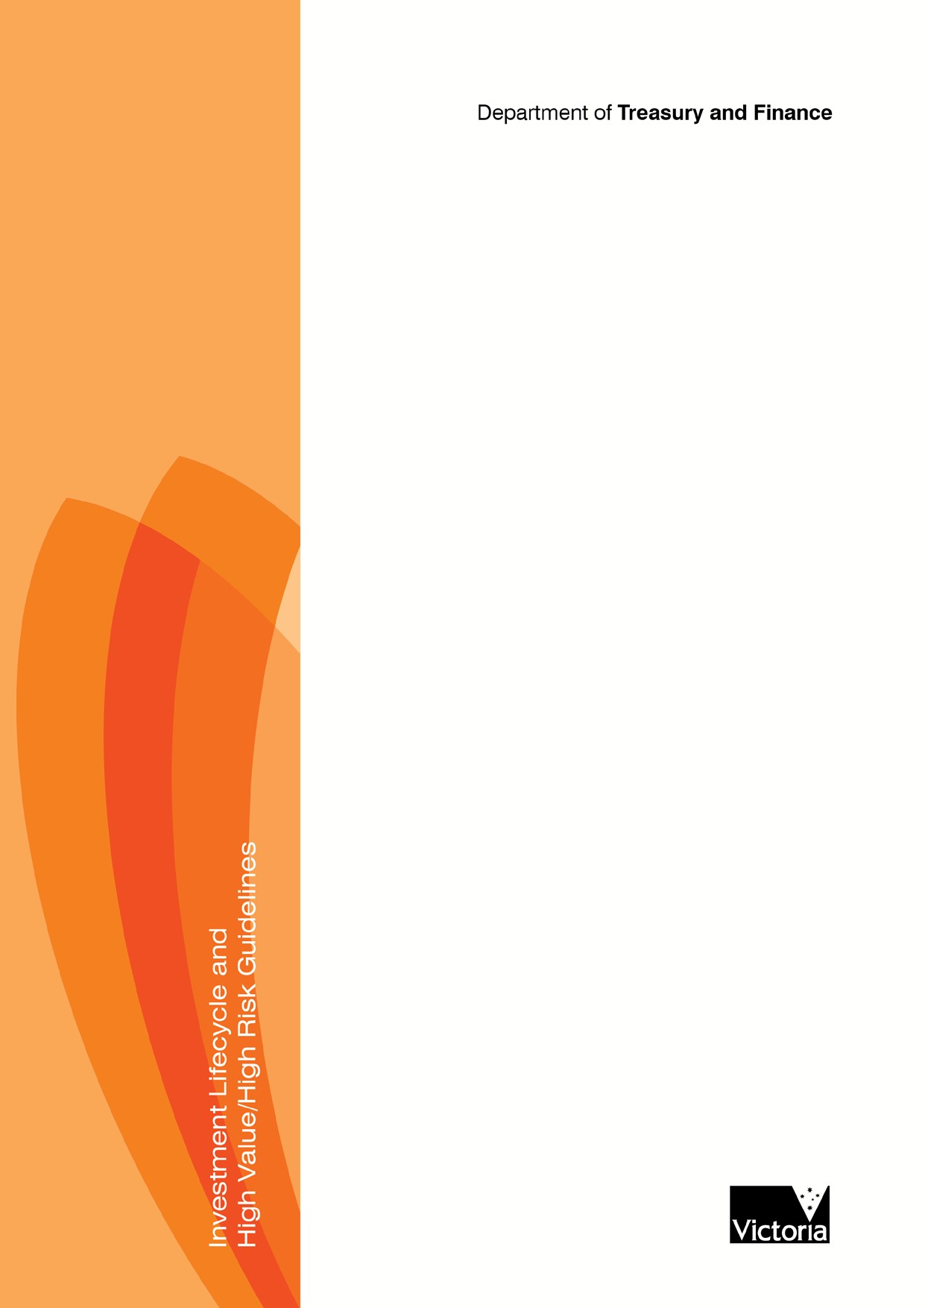

Department of Treasury and Finance

PROVE
Technical guidance Procurement strategy guideline

i

The Secretary
Department of Treasury and Finance
1 Treasury Place
Melbourne Victoria 3002
Australia
Telephone: +61 3 9651 5111
Facsimile: +61 3 9651 5298
www.dtf.vic.gov.au

Authorised by the Victorian Government 1 Treasury Place, Melbourne, 3002 Printed by XXXXXXXXXXX
Printers address XXXXXXXXXXXXX Printed on recycled paper.

© Copyright State of Victoria 2013
This book is copyright. No part may be reproduced by any process except in accordance with the provisions of the Copyright Act 1968.
ISBN 000-0-000000-00-0
Published June 2013.

If you would like to receive this publication in an accessible format please telephone 9651 0909 or email mailto:information@dtf.vic.gov.au
This document is also available in PDF format at www.dtf.vic.gov.au

Investment Lifecycle Framework

Contents

- Introduction 1
  - Context 1
  - Purpose of this guideline 2
  - How and when to use this guideline 2
  - Procurement strategy and procurement plan – how do they differ? 3
- Infrastructure procurement 6
  - Successful procurement 6
  - Every procurement is different 6
  - Procurement challenges and complexity 6
- Procurement analysis and decision making 8
  - Developing a procurement strategy 8
  - Stages of procurement analysis 8
- Procurement considerations 18
  - Accountability requirements for government procurement 18
  - Models that improve procurement success 21
- Procurement models used by the Victorian Government 28
  - Construct only (lump sum or fixed price) 28
  - Design and construct 29
  - Design, construct and maintain 29
  - Construction management 30
  - Project alliancing 30
  - Managing contractor 32
  - Early contractor involvement 33
  - Public-private partnerships 35
  - Competitive dialogue 36
  - Hybrid models 38

Department of Treasury and Finance

- Introduction

Context

This guide is a technical supplement to the Investment Lifecycle and High Value/High Risk Guidelines series (2012). It augments the Stage 2: Prove section of the investment lifecycle, which relates to developing a full business case. This guide supports Victorian Government departments and agencies to develop a procurement strategy as part of the full business case.
The Investment Lifecycle and HVHR Guideline series provides good practice guidance to assist departments to develop and deliver asset investments, from concept development through implementation to benefit delivery. Stage 2: Prove relates to developing the full business case, including analysis of a range of options to deliver a service requirement and solution definition. Figure 1 graphically depicts the investment lifecycle.
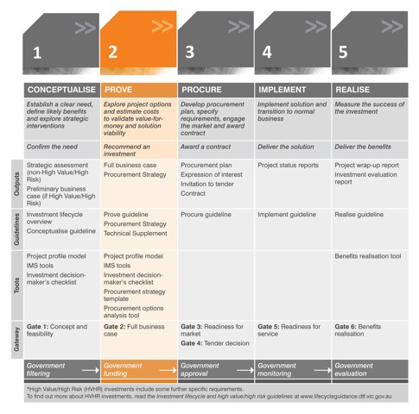
Figure 1 The investment lifecycle

1
A key business case component is a procurement strategy that documents procurement options, risks and opportunities to achieve the sought procurement outcome. Project deliverability is often dependent on the procurement method, and therefore the government decision to invest in a project extends to approving the general procurement approach to be used. This technical supplement assists users to develop a procurement strategy to support business case development and to provide decision-makers with confidence to deliver the recommended solution that maximises the opportunity for achieving greater value for money and improved outcomes.

Purpose of this guideline

This technical guideline supports practitioners to make the right decision to achieve successful procurement outcomes through developing a comprehensive procurement strategy.
    - Section 2 sets out the procurement strategy purpose, and how it is used to successfully procure outcomes.
    - Section 3 outlines a procurement strategy development process, key strategy components and the major decision points, including short-listing procurement models and identifying the recommended approach.
    - Section 4 outlines the key procurement methodology selection considerations, including accountability requirements for government practitioners, and factors that can impact on success.
    - Section 5 summarises the common procurement models.

How and when to use this guideline

This guideline is designed to inform the development of the procurement strategy component of full business cases for Victorian Government investments prior to the funding decision.
This guideline considers issues practitioners should think about when developing a procurement strategy. It is supported by practical tools and a template that can be used as the basis for strategy development.
This guideline is not intended to be a process compliance document. Each investment has unique characteristics, and the procurement strategy should be adapted to meet the specific needs of a given project.
This guideline does not purport to contain an exhaustive list of procurement categories.

Examples and case studies: A number of examples and case studies are included throughout this guideline to show how the presented theories and methodologies can be put into practice.

Note: Additional procurement strategy guidance material can be found within the Lifecycle Templates, Tools, Examples section of the Investment Lifecycle Guidance website:

    - the sample Procurement Strategy Template word document;
    - Procurement Options Analysis Tool, adapted from the Department of Transport’s process for undertaking procurement analysis and decision making.
(http://www.lifecycleguidance.dtf.vic.gov.au/subsection.php?section_ID=1&subsection_ID=19)

Procurement strategy and procurement plan – how do they differ?

The procurement strategy and the procurement plan are two different documents produced at different times within the investment lifecycle. The documents have different purposes, audiences and content requirements.
A procurement strategy is a high-level plan for achieving the sought procurement outcomes. It is part of the business case and is prepared during the proposal development stage of the investment lifecycle. The procurement strategy determines the procurement method that maximises the opportunity in meeting the government’s service objectives. It ensures procurement options, issues and risks inform the ultimate project approval and funding decision.
A procurement plan is developed after funding approval, to support solution delivery. A procurement plan is needed to guide and support the project team through the expression of interest (EOI), tendering, contract negotiation and implementation phases of a project, as well as to manage probity and procurement risks. Developing and implementing the procurement plan is addressed in the Stage 3: Procure document of the Investment Lifecycle and HVHR Guidelines series.
Table 1 explains the purpose of the two documents, outlines their content requirements, and clarifies commonalities and differences.

Plan element Procurement strategy Procurement plan

Relevant guideline Stage 2: Prove – Procurement Strategy Technical
Supplement
Stage 3: Procure

When undertaken Prior to funding approval. Forms an integral part
of the business case.

After funding approval. Forms an integral part of the project management plan.

Purpose To provide decision-makers (prior to funding approval) with confidence that the project team:
    - has given due consideration to procurement options;
    - has determined that the preferred option is appropriate and deliverable in the current market; and
    - has the necessary skills and resources to undertake the procurement and manage any related risks.

To provide the project team with a detailed, step-by-step plan to undertake the procurement, from options analysis and market sounding through tendering and contract management to post-occupancy performance.

Content requirements

Outline procurement options considered to deliver the recommended solution.

Reconfirm recommended procurement option and assess the optimal alternatives within the preferred methodology to deliver the recommended solution.

Outline the high-level summary of the methodology used to select the preferred procurement strategy for the recommended solution, including any short-listing processes and any market testing undertaken.

Document the market sounding and analysis to confirm deliverability and market engagement approach.

Outline the criteria used to select the preferred option. Present the ranking of each option against the criteria used to select the recommended procurement strategy, showing assessment of merits of alternative procurement methods for delivery.

Procurement management approach, including governance. Confirm procurement stages and provision of information.

Plan element Procurement strategy Procurement plan

Outline the recommended strategy required to procure the project and demonstrate, via a combination of the evaluation criteria and justification, how the preferred procurement strategy is appropriate for this investment.
Type of contract and contract management plan

Organisation’s experience and capability in delivering projects under the preferred procurement delivery method. (Note: this may be included within the business case governance section.)

Tender plan, including EOI, RFP, tender evaluation and contract negotiation and award

Procurement risks and mitigation strategies. (Note: this may be included within a broader risk plan within the business case.)

Probity plan

Stakeholder engagement

Stakeholder engagement to understand how they will receive the procurement, and how they will be affected by different procurement methodologies.

Plan to inform all stakeholders to ensure a common understanding of procurement objectives such as reference group, newsletters, notices, FAQs.

Market engagement
Targeted market engagement to understand how the market will receive the procurement and whether there is market appetite for the possible procurement options (particularly for unusual or complex procurements).
Create market awareness of EOI or tendering process to maximise market participation.

Risk management
approach Identification of risks and assessment of their
impacts to inform procurement analysis,
including:

    - determining how different procurement models will treat each risk, and the model that will manage each risk most effectively; and
    - appropriate and optimal risk allocation.

Procurement analysis should dynamically consider risks: where risks, issues or uncertainty are identified at any stage in the procurement strategy development process, decisions or assumptions to date should be reviewed. For example, where market engagement identifies information previously unknown, prior procurement analysis should be reassessed to determine the impact of new information and reconfirm that the proposed procurement is still justifiable.

Risk management at this stage will include identifying high-level treatment options.

Identification of risks and assessment of their impacts. Detailed consideration of preferred and alternative risk management and treatment strategies.

Managing and minimising risks as they occur throughout the procurement process.

Plan element Procurement strategy Procurement plan

Real options A triage process should be undertaken at the
preliminary business case stage to determine if a real options approach to project delivery is appropriate. If identified as appropriate, the full business case should explore the real options alternatives. This should include identifying the options, considering the external circumstances that will impact on each of the alternatives and will influence decision making, and outline the impact of alternative procurement methodologies on real options approaches.
Detailed analysis and documentation of real options as relevant to the selected procurement methodology. Includes clear identification of timing of real options decision making and implementation, as well as impacts of real options alternatives on tender and contract requirements.

Other considerations

The costing of the project should be consistent with the procurement approach and the risk allocation under the procurement approach.

The procurement approach should reflect the optimal risk allocation for the project.

Table 1 Elements of the procurement strategy and procurement plan

Successful procurement

Successful procurement is realising the planned investment outcomes through the delivery of assets and services whose quality represents good value for the given resource expenditure.
Procurement success is not only measured by how well an asset has been delivered but also how effectively it operates over its life to meet ongoing community service delivery requirements. Good procurement practices maximise opportunities and benefits while minimising and managing risks, and comply with government policies and public sector accountability requirements. Successful procurement can enhance innovation, risk management, conflict resolution and design quality. Poor procurement practices can lead to outcomes that do not meet the investment objectives and result in cost and schedule overruns or scope reduction.

Every procurement is different

There is no one-size-fits-all approach to procurement.
Each project has different characteristics and considerations impacting on the information needing to be documented within the procurement strategy. This guidance is not intended to be a compliance exercise. Not all the elements outlined in the procurement strategy template will be important to every project, and users are encouraged to tailor this guidance to best suit the size, risk, complexity and other project characteristics.

Procurement challenges and complexity

Government procures a wide range of goods and services, from routine, low-value commodity items to highly complex assets and services. Procurement processes, techniques and issues differ greatly across this spectrum. Government therefore needs to understand procurement challenges and complexity and manage their impacts.
At its simplest, government knows precisely what it wants to buy and can clearly specify the required asset or service. Furthermore, there is a competitive market that can readily meet the requirement. At the other extreme, procuring an asset such as a hospital can be considerably more complex and may require more specialised skills and expertise, complex governance and accountability structures and advanced procurement tools and processes. Sources of complexity in procurement include the following:
    - project scale: for example, several linked procurements being required to complete a larger project or a project with multiple parties involved;
    - project duration: a long-term arrangement with a service provider, as opposed to single, short-term delivery;
    - internal interfaces: for example, integration elements with other agency projects, policies and processes;
    - external interfaces: project exposure to market or demand risk, interconnection with existing assets, or other externalities such as timing and conditions of planning consent;
    - solution and scope: where it is not possible to fully define the technical solution upfront;

- technology: the use of unproven technology or proven technology in novel circumstances, including the development of bespoke solutions;
- financial structure: where it is difficult or undesirable to settle the financial structure of the project upfront, or where finance markets are tight;
- market: where there is inadequate existing market capacity to meet the need and a competitive supply market needs to be developed; and
- delivery risks: where there are high risks in managing the solution within fixed budget and timescales.
This document deals chiefly with the HVHR procurements, though many of the principles set out could apply equally well to more straightforward procurements.

This section outlines a process for developing a procurement strategy, including undertaking merits analysis of different project procurement approaches, and identifying key decision points.
This section aligns with the procurement guidelines published by Infrastructure Australia in the 2008 National Public Private Partnership Guidelines, including a process for short-listing and undertaking further analysis for selecting the preferred procurement method. Further information needing to be considered throughout the procurement analysis process is contained in subsequent sections of this document.

Developing a procurement strategy

3.1.1 Purpose of the procurement strategy

A good procurement strategy is one that identifies the most effective and efficient approach for procuring assets and services that is ‘best for project’ and ‘best for State’. A good procurement strategy is fundamental to successful procurement and project
delivery. The purpose of the procurement strategy is to analyse a range of service delivery
procurement models, and identify the procurement approach with the highest potential of
delivering the best outcome on balance for the given project.
The procurement strategy outlines the issues relating to a project that inform the procurement analysis. It also describes the process used to make the procurement model choice, and documents the decisions and outcomes. It further identifies how the preferred model needs to be tailored to best meet the project outcomes. Section 3.2 below outlines the general steps required to undertake procurement analysis and develop a procurement strategy. A sample procurement strategy template is available on the Department of Treasury and Finance’s (DTF’s) Investment Lifecycle Guidance website.
Note: It is recommended that procurement analysis is undertaken collaboratively by a range of project team members and stakeholders. The Procurement Options Analysis Process and Tool, available on DTF’s Investment Lifecycle Guidance website, outlines a collaborative approach to developing a procurement strategy. This tool is adapted from the Department of Transport’s Delivery Strategy Options Analysis Generic Process.

Stages of procurement analysis

Developing a procurement strategy should be underpinned by comprehensive analysis of the key characteristics, strengths and weaknesses of the different procurement methodologies as they relate to the given project.
Infrastructure Australia outlines a five-step approach to undertaking procurement analysis and developing a procurement strategy (see Figure 2).

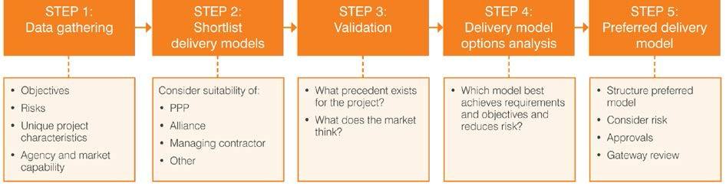
Figure 2 Stages of procurement analysis1

This approach supports practitioners in developing each key procurement strategy element, and informs the delivery model decision:

    - Step 1: Data gathering enables the practitioner to develop a sound understanding of project objectives, drivers, characteristics, risks and constraints, as well as the internal capability and capacity to manage these.
    - Step 2: Short-listing provides an approach for short-listing suitable service delivery models that could support the procurement, prior to commencing detailed analysis.
    - Step 3: Validation enables the practitioner to develop a sound understanding of the market appetite and capability to deliver the project.
    - Steps 4: Delivery model options analysis provides an approach for undertaking detailed procurement analysis to inform the delivery model choice.
    - Step 5: Preferred delivery model enables the practitioner to tailor the preferred procurement and contract methodology to meet the specific project objectives, characteristics and risks, to support implementation of the recommended approach.
These steps are detailed below.
It is important to note that this procurement analysis process is iterative, rather than linear. New information arising at any stage of the process will require reassessment and consideration of the previous stages and of any decisions made at that point in time. For example, any information obtained from the market during the validation stage (e.g. regarding procurement viability) should be fed back into the data gathering stage. The short-listing process should be reassessed and the market engagement strategy reconsidered. Practitioners need to be aware that their role is not just to follow the process but rather to constantly consider whether the process is still relevant.

Step 1: Data gathering

Decision point: What project objectives, characteristics, risks and controls will influence the procurement methodology analysis and selection process?

Selecting the most appropriate delivery model for the project requires a sound understanding of the project context and the early involvement of key stakeholders in the project planning and development. The first stage of a procurement process is gathering and documenting all information pertinent to the procurement. Much of the necessary data

1 Infrastructure Australia 2008, National Public Private Partnership Guidelines Volume 1: Procurement Options Analysis, Commonwealth of Australia, http://www.infrastructureaustralia.gov.au/public_private/files/National_PPP_Guidelines_Volume_1_Procureme nt_Options_Analysis_Dec_08.pdf
can be derived from information used to prepare other aspects of the business case. At a minimum this includes:

      - project objectives: including social, economic, environmental, cultural, security, safety or operational agency objectives, as well as any desired legacy benefits;
      - project characteristics and requirements: including project scope, location and value; design features, quality standards and required level of core and non-core services; site status; timing; and construction complexity and key challenges;
      - procurement and project risks: including all major opportunities and risks outlined in the project’s ‘risk management plan’, such as those relating to site issues, permits, design, materials and constructability, as well as public interest and political issues (it should also include project externalities that would change the project’s risk profile if they were to materialise); and
      - agency and market capability: identifying whether there is suitable internal human resource availability and capability to deliver the procurement given a range of potential delivery models, and the required level of governance and oversight. Different delivery methods and project sizes require specific levels of knowledge, skill, experience and resource requirements. Analysis should be undertaken to determine how well the agency’s existing capabilities and experience align with project objectives and risks. The agency must question if it can reasonably and affordably access sufficient people to perform the various roles and tasks required for the different procurement delivery models, and the experience to the deliver the type of procurement strategy contemplated. It will also need to consider the skills and resourcing required to manage project consultancies. This also includes analysis of market’s views on potential project delivery models and their appetite for risk.

Step 2: Short-listing

Decision point: What delivery models are the most suitable for delivering the project in the most effective and efficient way, and should be short-listed for further analysis?

There are a range of delivery models commonly used for delivering infrastructure procurement. These can be grouped into the following broad categories:

      - traditional, such as ‘construct only’ and ‘design and construct’ (including variants);
      - managed, such as ‘managing contractor’ and ‘construction management’;
      - direct managed;
      - relationship, such as early contractor involvement and alliancing; and
      - privately-financed models, such as public-private partnerships (PPPs).
An overview of commonly used delivery models is contained in section 5 of this guide.
The short-listing, or screening, process involves selecting the models best meeting project objectives and characteristics, for including in the detailed procurement analysis process. It should identify models that are not suitable for delivering the required procurement and eliminate them from further consideration. The short-listing process should consider the project scale, scope, risk and whole-of-life service opportunities:
      - Scale: what is the scale of the project, including lifecycle costs? Some procurement models, such as privately financed models, will only suit larger projects.
      - Scope: what is the project scope:
– Can the scope and outputs of the project be clearly defined?

- Is the construction straightforward and established or complex with untested challenges?
- Is the required technology proven and understood?
- Are there potential issues that may materially impact on the scope during the project (complex stakeholders relations, dependence on third-party input, unknown or unquantifiable risks)?
- Whole-of-life opportunities: to what extent can services (including both operational and maintenance services) be bundled as part of the project?
- Which services will the government continue to deliver directly and which services will it consider outsourcing to the private sector (for example, as part of a PPP arrangement)?;
- Are there any constraints on packaging of services?
- What are the expected efficiencies from packaging construction, operational and maintenance components, compared with other service delivery options?
- Can the service need be contracted over the longer term?
- Risks: What key risks are facing the project? What is government’s ability to manage these risks versus a private party? Is the cost of transferring responsibility for this risk optimal – that is, better than if retained by government? Is the government capable and appropriately resourced given that different delivery methods and project sizes require a specific level of experience and knowledge and resource requirements?
When deciding on the delivery model, the agency should not bias analysis of the available options, or presume that a particular model would be the most appropriate prior to proper analysis.
You should consider holding a workshop to involve a broad range of project team members and stakeholders in the short-listing process. See the Procurement Options Analysis Process and Tool on the DTF Investment Lifecycle Guidance website for further guidance.
The short-listing process should, at a minimum, consider PPP, project alliancing, design and construct, and other delivery models.

Considering PPP models

A PPP is a service contract between the public and private sectors where the government pays the private sector (typically a consortium) to deliver infrastructure and specified services over the long term. The private provider will build the facility and operate or maintain it to specified standards over a long period. The private provider usually finances the project.
PPPs are most beneficial where:
- it is possible to clearly define required outputs to allow a payment mechanism to be structured;

- competitive bidding can achieve significant innovation;
- the project has complexity and there is significant scope for innovation;
- there are opportunities for the transfer of certain risks to the private sector where they can be better managed (in some cases the private sector may prices the risks lower);
- whole-of-life asset management is achievable and cost-effective; and
- there is strong market interest in the opportunity.

Projects with a total capital value exceeding $50 million have the potential to result in value for money through PPP delivery. Consistent with the National PPP Guidelines, such capital expenditure should trigger evaluation of PPP as a potential procurement method for the
relevant project. The value could include bundling together a small number of similar projects. Projects valued under $50 million may also be suitable for PPP delivery if they exhibit sufficient value-for-money drivers. Projects below the capital expenditure threshold may also have a significant service component and therefore a significant net present value.
Practitioners should determine whether there are post-construction services that could be bundled with the construction contract and procured as one package. This decision requires an objective analysis of:
  - efficiency: outline any efficiency gains from bundling such post-construction services; and
  - quality: consider whether the post-construction services have been adequately defined (in terms of quality) and articulated in a contract.
For further information on these models and their suitability, see the National PPP Guidelines (2008).

Considering the project alliancing model

For alliancing models to be suitable, in general there must be:
  - significant uncertainty about risks that are unquantifiable and would result in large risk premiums under traditional delivery models;
  - risks that are best managed collectively with joint input from the government and the provider, improving the effectiveness and reducing the overall cost of the project; and
  - organisational capability, resources and culture to deliver a project through an alliance. For further information on suitability of project alliancing, see National Alliance
Contracting: Policy Principles (2011).

Considering design and construct models

Design and construct models are suitable where:
  - the principal does not need to specify their requirements in exact detail and where there is a broad understanding of what functionality is required;
  - little or no financial commitment is required before making a decision about proceeding; and
  - the client requires a total commitment for the time and cost of the project at a guaranteed fixed maximum price.
Design and construct models can be used for small, straightforward procurements or larger, more complex procurements.

Considering other delivery models

Consider the suitability of other delivery models described in section 5, as well as any others that may be appropriate.
Table 2 illustrates a short-listing approach based on assessment of project characteristics against the above procurement methodologies.

Category | PPP | Project alliance | Design and construct | Other

Scale

Project value over $100 million? Y Y Y Y

Category | PPP | Project alliance | Design and construct | Other

If not, can services be sensibly bundled to exceed this threshold?

Y n/a N/A n/a

Scope and outputs

Scope and outputs can be clearly defined Y N Y Y

Scope likely to change significantly prior to project completion and the potential change cannot be satisfactorily provided for in the specification
N Y N Y/N*

Whole-of-life opportunities

Services can be bundled together to create a long-term operational/maintenance opportunity
Y N N N

Risk**

A significant proportion of the material risks can be defined, allocated and potentially transferred to a private party
Y N Y Y

Unquantifiable risk exists that could have a material impact on project cost and objectives
N Y N N

Government is best-placed to manage material risks, with the cost of transferring this risk prohibitive

Table 2 Short-listing of suitable delivery methods 2
N Y Y Y

* While traditional models are typically used where significant scope changes are not expected, some traditional methods may be appropriate in these circumstances depending on the nature and timing of the expected changes.
** While some traditional models are best suited to known and quantifiable risks, depending on the nature of the risk, some forms of traditional procurement may allow government to manage material or unknown risks more effectively (i.e. design risk through the use of construct-only contracts).

Step 3: Validation

Decision point: What precedents exist for the project? How can government best engage with the market to initiate preliminary dialogue and interest?

It is important to have a sound understanding of relevant industry markets before making procurement strategy decisions. Engaging with market actors in the project’s early planning stages benefits both government and industry: government can learn about markets,

2 Infrastructure Australia 2008, National Public Private Partnership Guidelines Volume 1: Procurement Options Analysis, Commonwealth of Australia, http://www.infrastructureaustralia.gov.au/public_private/files/National_PPP_Guidelines_Volume_1_Procureme nt_Options_Analysis_Dec_08.pdf

trends and the potential impact of its intended procurement approach, while industry can prepare to respond to government’s requirements.
The extent of market engagement at the business case stage depends on the scale and complexity of the project. Market engagement to inform procurement strategy development may include identifying project precedents and analysing lessons learnt from similar projects. It may also include market soundings: accessing current information and intelligence (via a range of activities including industry forums and market surveys) on the potential capacity of industry to deliver the government’s project or program. It may be beneficial to request input from subject matter experts outside the tender preparation team to scope the market sounding process and advise on the best methods of approaching the market. It may also be appropriate to seek advice about strategies to influence or develop the market.
Market engagement may also include providing industry briefings: collecting project- specific information during the planning phase to facilitate preliminary dialogue with industry. This usually occurs after funding approval, and informs the development of the procurement plan. This step helps ensure a competitive market prior to inviting tenders. There are a range of issues that may be discussed at this point based on project specifics (subject to probity). Some include:
- scope of the project;
- project timelines;
- project-specific issues and requirements; and
- market interest and capability.
It is important to note that market engagement should have regard to confidentiality considerations at the business case stage of the project.

Step 4: Delivery model options analysis

Decision point: What delivery model and contract type best suits the procurement and therefore is recommended as the preferred procurement methodology? What adaptations are required to suit the project?

The fundamental purpose of the procurement strategy is to identify the most appropriate procurement delivery model for a given project. There are a large number of models to choose from, and selecting the right one is critical to project success.
Selecting a procurement model to deliver a project requires strategic evaluation of the inherent characteristics of each short-listed delivery model against the project objectives, characteristics, risks and other criteria. The detailed procurement analysis process must identify how successfully each procurement methodology can:
      - maximise project benefits:
- facilitate achievement or optimisation of project objectives and outcomes;
- best suit the characteristics of the project;
- optimise the schedule, cost and quality outcomes for the project; and
- deliver intended benefits whilst presenting value for money;
      - minimise project risks:
- provide the most appropriate risk allocation between parties;
- align key project risks with relevant characteristics of suitable delivery models to optimise risk management opportunities; and
- achieve the risk management objectives for the organisation and the project.

Considerations impacting on procurement model choice

Factors influencing the choice of delivery model include:

procurement approach characteristics:
  - implications of each model for the agency or market;
  - to what extent the chosen delivery model would still be relevant if circumstances changed;

design:
  - complexity of the design solution;
  - need for, and ability to achieve, complete design prior to tendering or construction commencing;
  - desire for design flexibility during construction;
  - obsolescence of the design and the ability to upgrade;
  - scope for innovation and benefits of having competing design solutions;
  - the agency’s desire to influence or participate in the development and delivery of the project including, for example, in the development of the design solution and construction method;

capacity and capability:
  - the capability and capacity of the market and the agency to successfully deliver the project under each short-listed model;
  - availability of suitable contractors;
  - the in-house resources and skills of the principal;

whole of life:
  - the merits of bundling capital and ongoing maintenance responsibilities;
  - how whole-of-life costs will be assessed under each model;
  - maintenance and disposal responsibilities;

alignment with government policies:
  - government policy and other political considerations;
  - level and nature of services that will be outsourced;

scale:
  - likely cost of the project;
  - thresholds (e.g. for consideration of PPP policy or project alliancing);

cost:
  - the need for strict cost control and/or certainty;
  - the degree of certainty about design and achievement of key performance indicators (KPIs);
  - the need for cost certainty;

project characteristics:
  - risk factors and particularly significant risks associated with a delivery model that could not be effectively managed, or that exceed organisational tolerance levels;
  - unique or unusual circumstances or factors;
  - risks that can be best managed collectively with joint input from all parties;

timing constraints:
  - model likely to best accommodate time constraints;
  - critical deadlines; and

market appetite:
– Is there a market to deliver what is proposed?

Delivery model selection

The chosen delivery model may be a variation to a model or hybrid of several models to optimise project or programs outcomes while concurrently managing risks that arise from the project or procurement activities. Hybrid approaches are most often used when a large project is disaggregated into a number of smaller procurement tasks.
There are a number of tools available to facilitate quantitative and qualitative evaluation. While such tools can provide a robust rationale for model selection, we suggest practitioners:
        - avoid formulae or methodologies that conceal their logic or fail to demonstrate the reasoning involved;
        - ensure sufficient intellectual expertise is available to analyse options from first principles;
        - ensure the tool is appropriate – there is no decision support tool fitting all projects;
        - do not rely on the assessment of a single tool; and
        - compare the result arrived at by applying the tool with an analysis from first principles to ensure the result withstands scrutiny when checked against other analytical methods.
You should consider holding a workshop to involve a broad range of project team members and stakeholders in the short-listing process. See the Procurement Options Analysis Tool on the DTF Investment Lifecycle Guidance website for further guidance.

Step 5: Preferred delivery model

•
Decision points: At a high level:
How will the preferred procurement model be tailored for the specific project?
What arrangements will there be for ongoing contract management?
Does the agency have the capacity and capabilities to deliver the project using the preferred procurement model?

Once a preferred delivery model is identified, it can be tailored to the project. The delivery model decision will define the contract management requirements; ongoing contract management provisions should be provided for within the procurement strategy. For example, the resources and expertise necessary for an agency to manage an alliance contracts would be different from those needed to manage a construct-only contract and therefore the associated contract management arrangements would be different.
A review of internal capability and capacity should be undertaken to ensure the department or agency has the necessary skills and resources to deliver the project using the preferred procurement model. The risk assessment must also be reviewed once a preferred delivery model is structured in detail. Prior to commencing preparations for going to market, the completed procurement strategy, including the preferred delivery model, should be approved as required by government processes. It is important to communicate the delivery model to the market when public announcements about the project are made.
Agencies should begin to consider the project tender strategy:

      - Will tenders be sought on the basis of a detailed design for a specific asset solution, or a high-level description of desired outputs and functional requirements?
        - Will you develop a design specification for a particular asset solution, or will you develop a statement of requirements that provides tenderers with flexibility on how these needs are met?
        - Will you invite tenders through a request for tender (RFT) against a design specification or a request for proposal (RFP) against a statement of requirements?
      - Will you invite tenders through a single-stage, open tender process or through a multi- stage select tender process?
        - Will the scale of the investment require an EOI process to be undertaken (required for HVHR projects)?
        - Will the complexity of the investment require a request for information, proof of concept or other significant market engagement process to be undertaken prior to tender?

Procurement considerations

Procurement is a complex process requiring consideration of many issues. This section documents some of the policies and issues practitioners must consider when developing a procurement strategy.

Accountability requirements for government procurement

Significant government procurement elements include upholding public sector accountability, managing public perceptions and enabling confidence in government projects and processes.

Key principles underpinning every Victorian Government procurement strategy and procurement decision to ensure public sector accountabilities are achieved are:

    - achieving value for money (VfM);
    - achieving efficient, effective and ethical use of resources;
    - maintaining probity and transparency;
    - encouraging open and fair competition; and
    - actively managing risk.
These principles are fundamental throughout the procurement process and also impact on the procurement plan and project delivery.

Value for money

VfM is an assessment of procurement success that weighs the cost of obtaining goods and services against the benefits they provide. A good procurement outcome is buying agreed quality and at the most appropriate price. It achieves maximum value for the resources expended. It balances purchasing costs of a good or service against a range of attributes, including quality, performance standards, suitability, risk exposure, policy alignment, timeliness, convenience, resource use and social and environmental impacts. VfM should be assessed on a ‘whole of life’ or ‘total cost of provision’ basis considering the long-term costs and sustainability of an investment as well as the immediate budget implications. Good procurement processes are mindful of building a positive legacy for future generations. VfM encompasses:
      - economy: careful use of resources to save expense, time or effort;
      - efficiency: delivering the same level of service for less time, cost or effort; and/or
      - effectiveness: delivering a better service or getting a better return for the same amount of expense, time or effort.
Including VfM in the procurement strategy: VfM should be an assessment criterion or component of both the short-listing and detailed procurement evaluation processes. The procurement strategy should assess each procurement option on its ability to affordably deliver the project objectives, and ensure that the preferred procurement approach does not introduce unnecessary or excessive transaction costs or risks that could reduce project delivery cost-effectiveness.

Effective, efficient and ethical use of resources

Agency procurement practices need to provide public confidence in government’s expenditure of public resources. Good procurement will avoid waste, ensure resources are used in a proper manner and in the community’s best interests, and ensure benefits are maximised. Procurements need to align with government’s policies, legislation and values.
Including effective, efficient and ethical use of resources in the procurement strategy: Identify the applicable policies and ensure the preferred procurement approach is consistent with and complies with these policies.

Probity and transparency

Probity and transparency: Probity is the evidence of ethical behaviour in a process. Probity is defined as complete and confirmed integrity, uprightness and honesty. It contributes to good procurement outcomes that accord equal opportunities for all participants.3 It enables government practices to withstand public scrutiny by promoting public sector integrity and confidence in the expenditure of public resources. Good procurement practices are appropriately competitive and provide equal opportunity to all parties. Procurement rules need to be clear, open, well-understood and applied equally to all parties to the process. Transparent and consistent procedures need to be established, understood and observed from the outset. These procedures need to align with the agency’s legitimate interests, their rules and guidelines, legislative requirements, relevant government policies and the VPS Code of Conduct.
Agencies must not benefit from supplier practices that are objectionable, dishonest, unethical or unsafe. They must also identify and manage any actual or perceived conflicts of interest. Ethical behaviour and good probity practices enhance the agency and government’s reputation in the marketplace, thereby maximising interest and participation in future work. Probity should be tailored to each individual process, and should be applied to each aspect of the procurement process.
Including probity and transparency in the procurement strategy: Market engagement processes informing the procurement analysis must be conducted in a fair and transparent manner that meets government probity requirements. The market engagement approach must not favour one market sector or participant over others, and must provide equal opportunity for all participants. The procurement analysis must be structured to assess procurement options on an equal basis, and not introduce bias towards one or more methodologies. For example, assessment criteria must enable the procurement analysis to fairly evaluate model suitability, and must not unfairly represent one or more methodologies.

Encouraging open and fair competition

A procurement should approach the market in an effective and appropriate way to provide reasonable access for suppliers to government procurement opportunities. Government should have confidence that competition can be maintained throughout the procurement process, and that it will receive the most competitive response possible.
This includes ensuring that competent suppliers are not deterred, either by poor processes, lack of advertising/information, inadequate response times or cost of tendering.
Including open and fair competition in the procurement strategy: The selected procurement method should suit market circumstances and be able to provide the opportunity broadly across the market. Agencies should have a thorough understanding of the market conditions,

3 Department of Finance and Deregulation, Australian Government, ‘Guidance on Ethics and Probity in Government Procurement - FMG 14’, http://www.finance.gov.au/archive/archive-of-publications/fmg-series/14- guidance-on-ethics-and-probity.html
capacity and interest in the project or initiative, and ensure that market engagements and testing processes are structured to encourage maximum participation. Adequate and timely information must be provided to all participants to raise awareness and interest in the offer and encourage competition.
Ensure the short-listing and detailed procurement analysis processes consider a range of procurement approaches to provide the opportunity broadly across the market. Design evaluation criteria to promote competition and elicit a contestable outcome.

Risk management

A successful procurement strategy will identify the delivery model that optimises project outcomes – not necessarily the model that has the lowest risk. The procurement and delivery of assets is inherently risky, and investment delivery requires negotiating and managing a wide variety of project externalities and uncertainties. Practitioners need to identify and assess risks they may face, identify appropriate risk treatments and evaluate the consequences of the occurrence of the residual risks on the project in terms of time, cost and performance. Treatments may include the development of costed contingency plans, risk transfer or sharing, inclusion of specific contract clauses, etc. The cost of risk treatment needs to be built explicitly into project cost estimates, and consider the impact on quality and schedule.
ISO 31000 provides an internationally recognised standard for best practice risk management. Departments are encouraged to align their risk management practices with this standard.
Risk should be managed by the party most able to control the risk and deal with it effectively. When procuring an investment, consideration should be given to determine whether the private sector can reasonably be expected to take responsibility for particular risks. Excessive or inappropriate risk transfer to contractors may result in high tender price premiums. If a contractor has not adequately allowed for a risk that is later realised, this may result in claims, disputes and reduced quality to the government. By allocating responsibility for a risk to the party best able to manage that risk (and assuming the risk has been appropriately priced), the government may minimise the overall project cost.
It is important to remember that, within a particular procurement method, there can be great variance in risk allocation depending on the form of the contract. Selecting the best procurement method is only one step in delivering the project; tendering for the project is also a key step to ensure the project objectives are achieved. Please refer to Stage 3 of the Lifecycle Guidelines for more information.
How risk management should be included in the procurement strategy: The ability of a delivery model to support efficient and effective management of project risks is a significant component of procurement analysis. When making the delivery model decision, consider the following approaches to risk:
      - Identify the model that optimises project or program outcomes, and not necessarily the model that has the lowest risk.
      - Conduct a detailed risk assessment incorporating the proposed delivery model.
      - Identify risk treatments where appropriate. Treatments may include developing costed contingency plans, risk transfer/sharing, adding specific contract clauses, etc. The cost of risk treatment needs to be built explicitly into project cost estimates (and where relevant also consider impact on quality and schedule). This should be done generally as part of the business case; however, it is valuable to assess differences in risk treatment under disparate procurement models.

      - Give careful consideration to the risk treatment strategy, risk ownership and risk allocation under the project delivery model. Risks should be allocated to the party most capable of managing the risk. Consider whether the private sector can reasonably be expected to take responsibility for particular risks. If a contractor has not adequately allowed for a risk that is later realised, this may result in claims, disputes and reduced quality to the government. By shifting responsibility for a risk to the party best able to manage that risk (and assuming the risk has been appropriately priced), the government may lower the overall project cost.
      - Consider another delivery model if, in the planning process, unusually high risks are identified or possible consequences lie outside the organisation’s tolerance for risk and either:
        - a management strategy is not available; or
        - the costs outweigh the benefits.
      - Stress test the delivery model. Check the delivery model’s sensitivity to circumstances when certain risks materialise. Examine the risks identified in the risk assessment process and consider the consequences of these under the preferred delivery model, including if modification to the models will result in more effective risk management. The model may also be modified or changed should an unmanageable or intolerable risk appear.
      - A proactive risk management process will make a positive contribution to cost management, schedule and quality outcomes. This approach supports the VfM objectives.
Risk management occurs throughout the development and delivery of a project. Risks and their mitigation strategies should be first identified in the strategic assessment and business case for an investment. Risk management will continue through the procurement and implement phases of the investment lifecycle. It is important to ensure that a consistent risk management approach is adopted throughout the investment lifespan.
If new risks are identified through the procurement analysis, these should be fed back into the overall risk management plan for the project, and may require a reassessment of the business case recommendations.

  - Trends that improve procurement success

Multiple procurement models within one project

Project bundling or packaging can occur across a portfolio of projects where a number of small projects are procured as a bundle rather than on an individual basis.
A number of like projects, with similar or complementary procurement objectives, can be bundled together to increase VfM outcomes.

Project bundling or packaging can also occur within a project where different project elements are procured in two or more separate bundles.
A common example of packaging/bundling in infrastructure is separating responsibility for constructing an asset from maintenance requirements. However, this can be extended to separating responsibility for different elements of design, construction, operation or maintenance.
Project bundling/packaging is particularly relevant for large, complex investments where there are numerous disparate components with different deliverables and risks, and where delivery is likely to require different skill sets. Using bundling techniques, different procurement models can be applied within a single project to deliver disparate project elements or groups of elements.
Bundling or packaging can be used to increase the likelihood of meeting procurement objectives. It enables different procurement models to be applied to suit the needs of specific project components, rather than using a single approach that suit some components but not others. It can maximise VfM, either by breaking a complex requirement into separate, simpler procurements, or by grouping like elements to achieve efficiencies. It can also minimise risk by treating any components that have a different risk profile from other elements separately. However, it can also increase costs, primarily through more complicated procurement processes and contract management and administration activities. It is therefore important to assess the likely net benefits of using bundling techniques within the procurement strategy.

When to consider the potential of project bundling/packaging:
Project bundling/packaging should be explored within the procurement strategy:
      - Data gathering: Examine the key procurement risks to determine if any have significantly different risk profiles. This may identify issues and risks that cannot be easily managed within the same framework as other issues. Also explore contractor skills and capacity to manage each project component to identify if any elements will require different skill sets. This analysis could identify project components that would be best delivered using different procurement approaches.
      - Evaluation of procurement models: The short-listing process should consider whether project bundling will be appropriate for the given project, and should consider different packaging options. Taking into consideration specific project attributes and risks, the following criteria has been developed by way of example to support a high-level comparison of alternative packaging/bundling approaches:
        - scale and contractor capacity – the capacity of a particular contractor to manage and undertake the scale of works for the project and/or packages/bundles;
        - skill sets and expertise – the ability of the contractor to provide the appropriate mix of skills and expertise for the project and/or packages/bundles;
        - delivery timeframes – the impact on the time required to release the project and/or packages/bundles to the market and on completion of the works;
        - risk (and opportunity) profiles – the risk profile within the project and/or packages/bundles and the ability of the contractor to best manage those risks (particularly interface risks) or access opportunities;
        - stakeholders – the role and influence of multiple stakeholders to the project and/or specific packages/bundles, and the affect these may have on delivery of the project and/or packages/bundles; and
        - State resources – the extent and experience of public sector resources required to support delivery of the project and/or packages/bundles.
If the short-listing process recommends bundling project components, detailed procurement analysis is separately required for each project package. For each package of project components, the project team should assess the likely procurement approaches against the project criteria and identify the recommended approach for that package of project components. Each detailed assessment should be documented within the procurement strategy to provide decision-makers with the confidence that each component will be procured using the most appropriate methodology, and that the overall approach will offer the best VfM.
      - Preferred delivery model: The procurement strategy should document how each of the procurement components are to be procured where there are multiple procurement packages. This should include documenting the interfaces between the different packages and discussing risk sharing and management. An example includes the Regional Rail Link:

Case study – Regional Rail Link

The procurement strategy for the Regional Rail Link project (RRL) assessed three broad approaches to select the most best procurement solution:
- procure the project as a single package;
- procure the project by discrete geographical sections – all components of the project within a particular geographical section could be packaged together (i.e. a section of track together with all station(s), and other works in that section); or
- procure the project as discrete packages of work – separate disciplines required for the project may be packaged for procurement, such as all station developments, grade separations, track and signalling, a tunnel, etc.

The approach chosen was to procure the project in six separate work packages by geographic region. It included three alliance procurements and three design and construct procurements.
The project team assessed the scale of RRL as being difficult to deliver as a single project in the current local market, and proposed to break the project into smaller packages to deliver separately.
The project spanned a large area, with variable geographical characteristics that suited different procurement models. For example, in the brownfield sites through Footscray to Deer Park, the project interfaces with existing metropolitan rail network elements. Infrastructure delivery required considerable engagement with current rail operators and franchisees. An alliancing model, encouraging cooperation across all parties, best suited procurement objectives in these areas. In the greenfield sites between Deer Park and Werribee there was less interface with other existing networks and therefore less need to manage multiple stakeholders with different needs. In these areas, design and construct procurement models were considered most suitable.

Project staging and structuring

Government often delivers projects to meet long-term service delivery requirements within an uncertain operational and political environment where the needs of users are constantly evolving. In order to manage uncertainty, which can have the potential for later investment regret, government should embed flexibility into its investment and procurement processes in order to ‘insure’ the investments against such risks.
There are multiple sources of uncertainty, including future user needs and demand, future technology and future market and political factors. Real options is one method of introducing flexibility into government procurement systems to manage these uncertainties and provide insurance through feasible options that support cost-effective adaptation exercised in a timely manner.
Real options is a method of evaluating investment decisions in a way that takes into account uncertainties about the future and the need for flexibility. It recognises the dynamic complexity that further information and future decisions can introduce to a project.
A real option is the right – but not the obligation – for the investor to undertake certain business initiatives and actions in the future to optimise the opportunities and risks of an investment over its lifecycle and mitigate the risks that an investment will be regretted. Real options does not eliminate the chance of regret but seeks to limit the extent of the regret. Real options:
      - Relate to tangible assets: They are called ‘real’ options because they relate to physical assets rather than to financial contracts or instruments.
      - Provide a right to undertake an action, but no obligation to do so: For example, when investing in a new bridge, the government may engineer the asset to have the access and strength to carry trains, even though there is no current need for such a service. The government is providing the capacity to meet a future service requirement, should it eventuate. This is building a real option into the system – the government will have the right but not the obligation to create a metropolitan rail line whenever they chose to do so. If the service need does not eventuate, the government is not required to exercise the real option.
      - Are defined in advance, which gives them value: Real options are distinguished from ‘choices’ or ‘alternatives’ by being defined in advance (usually via a contract). It is the uncertainty that occurs from pre-defining the action that gives the option value.
Real options provide strategic benefit in having future flexibility to alter the plans made today to manage uncertainties about the future. They provide managerial flexibility to respond to prevailing investment conditions impacting on the cost-benefit proposition of either holding and or exercising investment options. In this way, real options is a risk management approach that focuses on opportunities provided by the upside of risk, as well as negative externalities. The following examples of real options provide management with the flexibility and ability to respond in real time to unfolding events (see Table 3). Such options are not mutually exclusive and can operate sequentially.
Real options can be used in parallel with any procurement model.

Real option category | Description of real option | Example of real option
Option to defer or wait before commencing or committing to the investment | An investment may be deferred indefinitely without relinquishing the right to invest in the project. The investor is free to choose the optimal time to start the project given what is known about the uncertainties. | Government procures land within a growth-area subdivision to cater for future service demand. Government buys the land prior to property value increases driven by development. They therefore procure the right to construct a facility at some time in the future when there is a service demand. Common uses of this type of real option include schools, police stations, health services, road and rail corridors and train stations.
Option to stage the implementation of the investment (acquire incrementally) | Project implementation can be staged to introduce a series of decision points into the process. At each decision point (i.e. at the end of one phase and beginning of another) government has the option and flexibility to continue or abandon the project depending on new information. | Government requires a new bespoke information and communication technology (ICT) system. It appoints a contractor to deliver the system, with the project comprising three stages: (1) develop a system specification; (2) develop a prototype; and  (3) deliver the end product.  Government can exercise the option to continue or abandon the project at either the end of Stage 1 or 2 based on an assessment of whether the specification and/or prototype is capable of satisfying the service requirements.
Option to alter the scale of the investment (e.g. to expand, to contract, to shut down and to restart) | A contraction option provides the flexibility to reduce service delivery or production output if conditions become unfavourable.  An expansion option provides the flexibility to expand the current state to increase service delivery or production output.  The flexibility to shut down means that, once an investment is in operation, the government has the option to shut down the facility. The shutdown may be temporary, such as during periods when it cannot recover enough revenue to meet its operating costs, or permanent. | Government delivers new public TAFE services through a private sector facility. Government is initially uncertain whether there will be demand for these new courses:  Contraction option:  The government may need to reduce the level of services it provides at a point in the future. The government ensures it only pays for the capacity and space it uses on an annual basis.  Expansion option:  Demand is greater than anticipated. Government may exercise an option to expand the level of service it provides by exercising an option to take up additional space within the facility at a previously agreed, competitive cost.  Shut down and restart option:  Demand for the new courses may decline in any given year. Government can exercise an option to shut down the service provision in years of low demand at low cost, to be re-started if demand increases. An option to shut down may be permanent, for example, where changes to industry practices or technological advancement drive obsolescence in a skill set.
Option to abandon the investment proposal or exit the project during delivery | Some projects have a high degree of uncertainty regarding its potential success or failure. In these instances, an option to abandon can enable government to permanently dispose of an investment if the project becomes unsuccessful or market conditions decline severely. Agencies can realise the resale value of capital | Government purchases land for future expansion of a facility. Demand increase never eventuates. Government has the option to sell the land.

Real option category

Description of real option Example of real option

equipment and other assets in a declining market.

Option to switch outputs or inputs during delivery

If prices or demand change, agencies can change the output mix of the facility (product flexibility). Alternatively, the same outputs can be produced using different types of inputs (process flexibility).

Output shifts:
When building a rail network, government includes the functionality to allow for future changes to rolling stock. It enables different types of trains to be run on the network, allowing for different suppliers and changes to characteristics (such as double-deck carriages).
Input shifts:
A coal-fired power station may plan for increased financial penalties for sulphur emissions by using an option to switch from high- to low-sulphur coal sources in the event that such penalties impact on revenue. Similarly they could switch to a mixture of coal and biomass in the event that a carbon tax impacts on electricity generation costs.

Growth options Options that invest early in the
flexibility to upgrade in the future
at a much lower cost.

Government constructs a new bridge to a growing suburb, and provides the capacity to add extra lanes. There is no current demand for a wider crossing; however, government is planning for increased service demand in the future.

Table 3 Types of real options

When to consider real options in the procurement strategy
The project team should determine whether real options is applicable to a project prior to developing the procurement strategy. A triage process should be undertaken at the preliminary business case stage to determine if a real options approach to project delivery is appropriate. If the real options approach is identified as potentially beneficial to project delivery, the procurement strategy should explore all alternatives and focus the effort on those investments where the benefits are likely to be greatest.
Real options can help inform the decision on how much should be invested in the proposal’s development (e.g. feasibility studies or pilots) before it is approved or rejected. Real options are of significant value when investments are characterised by high levels of uncertainty and can be structured to encompass flexibility/optionality at milestone stages. Real options is particularly suitable for ICT projects, as it is a way to address risks that are identified, fully scoped/understood further into development.
Real options is less relevant when the investment decision needs to be made upfront as an ‘all or nothing’ commitment. For example, staging options are most valuable when investment in the next stage can be determined on additional knowledge of costs or of risks to date and their likely resolution before the next investment stage is reached. Some key limitations of real options include:
      - If the flexibility being considered is too costly to procure, preserve or exercise, then real options will only identify that the flexibility has no value, and not provide the investor with any benefits.
      - Flexibilities must be identified in order to value them.
      - Flexibilities may be very investor-specific.
The procurement strategy should consider the following issues relating to implementing real options:

- Data gathering – Identify sources of project uncertainty. Consider external circumstances or trigger points impacting on each of the alternatives and influencing decision making. Determine the capacity of internal and market resources to manage uncertainties and real options.
- Evaluation of procurement approaches – The short-listing process should eliminate any procurement methodologies that will not support flexible project delivery where required, and will therefore not accommodate a real options approach to managing uncertainty. The detailed evaluation process should consider how each potential procurement model will support each of the real options being considered. Some VfM analysis is required to assess the cost of insuring against uncertainties versus the cost of those uncertainties being realised.
- Preferred delivery model – Document how the EOI, tender and contract documentation will need to be tailored to manage potential implementation of any real options alternatives.

ICT-specific guidance

Many ICT projects are inherently difficult to plan and deliver when compared with traditional asset or service delivery projects.
This is due to a number of reasons. First, the ICT environment is rapidly evolving, and there is more likelihood that government will be inexperienced in delivering investment objectives and deliverables. This leads to increased risk and uncertainty in the procurement approach and delivery solution. ICT solutions often have shorter operational lifecycles than other assets, impacting on maintenance and renewal cycles. They also often have increased complexity in the solutions implemented, a different cost structure for project delivery, and increased change management requirements, compared with a construction project.
Victorian Government has identified several key actions that should be considered when developing a procurement strategy for an ICT project:

- Early engagement with the vendor market – It is likely the potential technical and business solutions arising from an ICT problem will require extensive definition and refinement, and hence early engagement with the market is key.
- Active contract management – ICT procurements are likely to be affected by contractual issues such as contract variations, performance management and payment schedules. The procurement strategy must explicitly consider and address these issues.
- Attend to roles and responsibilities – Large ICT projects create highly complex and detailed relationships between the vendor and the client. Therefore, experienced and appropriately skilled staff need to be appointed to the roles of delivery management, commercial management and vendor management.
- Staged procurement – Consider a staged approach to the development and implementation of ICT-enabled projects. This involves the development and implementation of an ICT project to be separated, re-evaluated and re-costed at stages along the project’s lifecycle.
- Real options – Using real options can be particularly useful for managing the delivery of ICT projects.
For more information on developing and implementing ICT projects, please refer to the supplementary ICT-specific guidance.

Procurement models used by the Victorian Government

The choice of a procurement delivery model for each project is one of the most critical steps in determining the project’s success.
The Victorian Government’s public construction projects are tendered and delivered through a variety of procurement models. These include:

- construct only (lump sum or fixed price contract);
- design and construct;
- design, construct and maintain;
- construction management;
- managing contractor;
- early contractor involvement (ECI);
- alliance contracting; and
- PPPs (Partnerships Victoria projects).
Each procurement model has its own strengths, weaknesses and characteristics suiting different conditions and circumstances.
These delivery models are often combined to create a hybrid delivery model. On a large project, parts of the project may be packaged separately, resulting in the use of a number of different contracts and delivery models. These different approaches and their interfaces need to be reflected in the procurement strategy.
Where appropriate, departments are encouraged to consider other models in addition to those described in this guideline. This could include models specifically relating to their service area, for example, using franchisees to procure transport services.
The below section outlines these common procurement approaches. Their key characteristics are then summarised in Table 4.

Construct only (lump sum or fixed price)

Under this commonly used form of contract, the State has responsibility for the project’s design and engages a design team to develop the design documentation. The State then separately procures a contractor to deliver the construction component of the project. The design documentation forms part of the tender specification for this procurement process. The contractor tenders a price for the works subject to any adjustments, such as variations, provided for in the contract. Irrespective of the actual cost of the works, the contractor is entitled to be paid the contract sum as agreed between the parties prior to commencing the works. In practice, the construct-only contract may exceed the original contract sum if the project is not properly planned and managed by the State.
Figure 3 illustrates the contractual relationship of the ‘principal’ with the design team and the contractor in a construct-only model

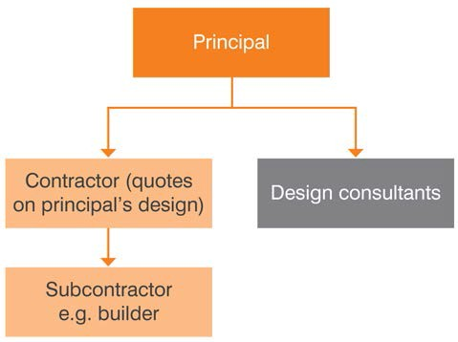
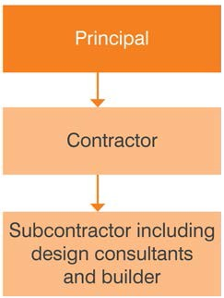

Figure 3 Typical construct-only structure

Design and construct

For a design and construct contract, the State prepares a design brief outlining the functional specifications and key user requirements for the works. This is less fully developed than the design documentation required for a construct-only contract. The State (principal) then tenders and enters into a single contract with a contractor, who is required to provide detailed design (consistent with the design information provided) and the subsequent construction of the works described in the design brief.
Figure 4 illustrates the contractual relationship of the principal with the design team and the contractor in a design and construct model.

Figure 4 Design and construct structure
A common variation to the design and construct model is the design, novate and construct model. Under this arrangement, the principal initially engages a designer to prepare a schematic design. The principal then engages a construction contractor who in turn enters into a subcontract with the same designer. The contractor then takes on full responsibility for the design including payment of the designer’s fees. This model ensures the continuity of the designer’s input from project inception to completion.

Design, construct and maintain

In this model, the contractor has ongoing maintenance obligations in addition to design and construction. Some of the asset lifecycle risk is therefore transferred to the contractor. This encourages design efficiency and quality construction to reduce long-term costs. Figure 5 illustrates the contractual relationship between the principal and the contractor in a design, construct and maintain model.
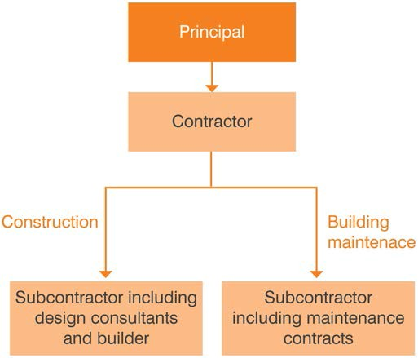
Figure 5 Design, construct and maintain structure

Construction management

In the construction management approach, the principal engages a construction manager (contractor or consultant) to manage construction works on its behalf. The principal manages the project scoping and engages the designer directly. The principal also engages the trade contractors directly, although these contracts are entered into by the construction manager as the principal’s agent. The construction manager performs a managerial and coordination role (without delivery risk) and is generally paid a fee based on a percentage of the value of the works.
Figure 6 illustrates the contractual relationships involved in a typical construction management arrangement.

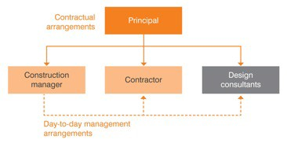
Figure 6 Construction management structure

Project alliancing

Normally, project alliancing is used to deliver larger, more complex and high-risk infrastructure projects (with capital costs exceeding $50 million), and where the owner has particular capability to contribute its skills and expertise to deliver the project.
Projects suitable for delivery as alliances are generally characterised by one or more of the following factors:

    - The project has risks that cannot be adequately defined or measured in the business case or prior to tendering.
    - The cost of transferring risks is prohibitive.

- The project needs to start as early as possible before the risks can be fully identified and/or project scope can be finalised.
- The agency has superior knowledge, skills, preference and capacity to influence or participate in the development and delivery of the project.
- A collective approach to assessing and managing risk will produce a better outcome. In project alliancing, the principal or owner collaborates with one or more private sector
parties (non-owner participants (NOPs)) to share risks and responsibilities in delivering the
construction phase of a project. Alliance contracting is characterised by a number of key features, which generally require the parties to work together in good faith, act with integrity and make best-for-project decisions. Alliancing arrangements aim to achieve collective responsibility between parties. The alliance participants work as an integrated, collaborative team to deal with key project delivery matters, share risks, responsibilities and rewards in delivering the construction phase of project. The alliance contract and supporting structures promote a positive culture based on ‘no-fault, no-blame’ and unanimous decision making, requiring all participants to find ‘best for project’ solutions.
Alliancing is a complex delivery method, and success is based on four interdependent success factors of:
- an integrated collaborative team;
- the project solution;
- the agreed commercial arrangements; and
- the agreed target outturn cost (TOC).
The owner selects two proponents to compete on targets for cost schedule and other key parameters. Through collaboration, the owner takes the lead in providing understanding and guidance on project objectives in the scope and risk development undertaken by the proponents through the TOC development process. The owner’s decision in selecting its preferred proponent to deliver the project is based on a balanced judgement of the price and non-price attributes of the TOC development outcome (including the proponent’s proposed project solution) and the team capability it offers. This includes the commercial and legal arrangements, which have a significant implication on the final actual price paid. If actual delivery is better than the agreed targets, parties share the reward (‘gain share’). Conversely, if delivery does not meet agreed targets, a pre-agreed ‘pain-share’ formula applies.
Under an alliance model, the non-owner parties are typically guaranteed reimbursement of their direct project costs and payment of corporate project overheads in an open-book arrangement.
An alliance project has a collective approach to risk, which means that the owner will share in construction and design risk (and opportunities) and is exposed to project risks that it would normally transfer to another party under a ‘hard dollar contract’ or a PPP. Therefore, it is critical that the owner has a thorough understanding of the risks it faces under the alliance contract and has appropriate capabilities and resources to manage the contract.
The Victorian Government policy and guidelines have now been published as the National Alliance Contracting Policy and Guidelines. See: http://www.infrastructure.gov.au/infrastructure/nacg/index.aspx.
Figure 7 illustrates the typical alliancing model.
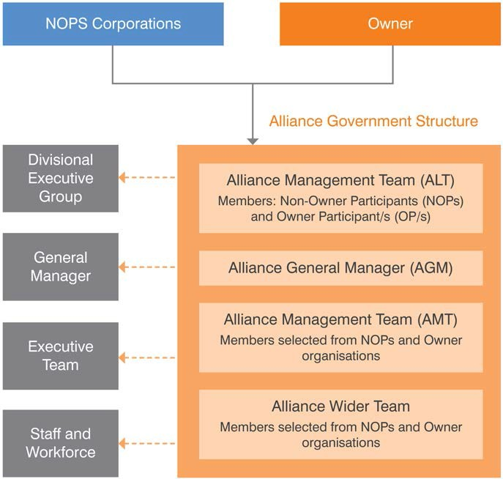
Figure 7 A typical alliance model

Managing contractor

This form of contracting involves the principal engaging a head or managing contractor through a competitive process to manage the development of the design, coordinate production of construction documentation and manage construction on its behalf. For this to work, the managing contractor is paid actual sub-contractor costs and the tendered management fee, which can either be a lump sum or a percentage of actual costs. They may also receive incentive payments for achieving costs and schedule targets, although these should only be used in circumstances where exceptional performance is required to meet project objectives, and should not be applied to ‘business as usual’ requirements.
The managing contractor is engaged early in the process to provide constructability input. Existing design and designers can be novated across to the managing contractor to prepare detailed designs and confirm that the cost is within the budget, or else the contractor engages consultants to complete the design. The principal collaborates with the managing contractor on the design and delivery aspects of the project. The principal has the ability to provide input into the design development and the opportunity to influence the design and construction process.
There are many variants of the managing contractor form of delivery to suit specific project type and economic circumstances (see Figure 8). The common variable elements are degree of design, the type of tender process, and how the fee and the estimate of the works – that is, guaranteed maximum price – are finalised. Because of this and the sophisticated nature of the delivery process, the managing contractor approach needs experience from all participants for it to work well. It is important to note that the planning and procurement strategy of all forms of relationship and collaborative contracting, including managing contractor, must be consistent with the National Alliancing Policy that applies to all departments and agencies.
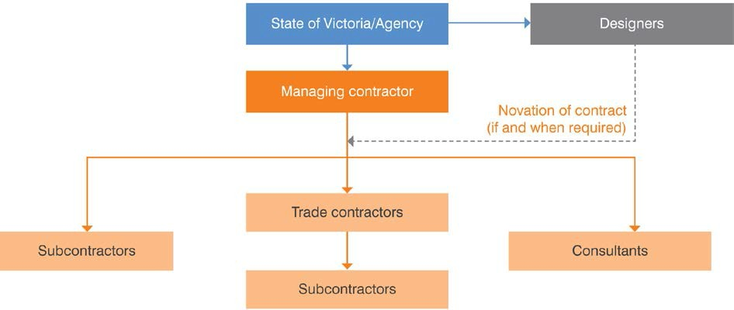

Figure 8 Managing contractor structure

Early contractor involvement

The ECI model is a collaborative procurement contract followed by a separate contract for construction (generally a risk-allocated traditional design and construct contract). ECI is split into two phases.
    - phase 1 – The ECI phase; and
    - phase 2 – construction phase.
In the ECI phase, two suppliers are engaged under an ECI agreement to work collaboratively with the principal in parallel (see Figure 9). They develop the design, a detailed project plan and commercial proposal for the construction phase, which includes a risk-adjusted price for the construction phase to be delivered as a lump sum contract. Selection for the ECI phase is based primarily on non-price criteria, although limited price criteria may also be considered. Payment for the ECI phase is based on a fixed fee negotiated as part of the ECI agreement. Generally this fee should not exceed 50 per cent of the estimated costs incurred by the suppliers for participating in the ECI phase.
The competition between the two suppliers in this stage prior to the construction contract award drives early innovation capture and a robust tender price for the construction phase. Following completion of the ECI phase, the principal selects one of these two suppliers for the construction phase under a design and construct type contract. The constructor’s team takes the time, cost and quality risks by assessing the proposed project solutions and the tendered prices. In the exceptional circumstance that the principal cannot reach an acceptable commercial arrangement with either supplier at the completion of the ECI phase, the client may choose to go to the market for other proposals.
It is very important to note that the planning and procurement strategy of all forms of relationship and collaborative contracting including ECI must be consistent with the National Alliancing Policy that applies to all departments and agencies. In exceptional cases a ‘single’ ECI process may be used when approvals as required under the National Alliance Contracting Policy Statement have been obtained. This involves the principal collaborating with a single supplier in the ECI phase to develop a preferred design and negotiate a price. Once this negotiation is complete, the works are the subject of a ‘design and construct’ type contract, with the constructor’s team taking the time, cost and quality risks. This non- competitive ECI process may potentially only be acceptable when there is a scarcity of unique skills in the industry. In such cases the client must engage independent project reviewers and estimators to verify the scope of works and costings offered by the supplier in the non-competitive process.
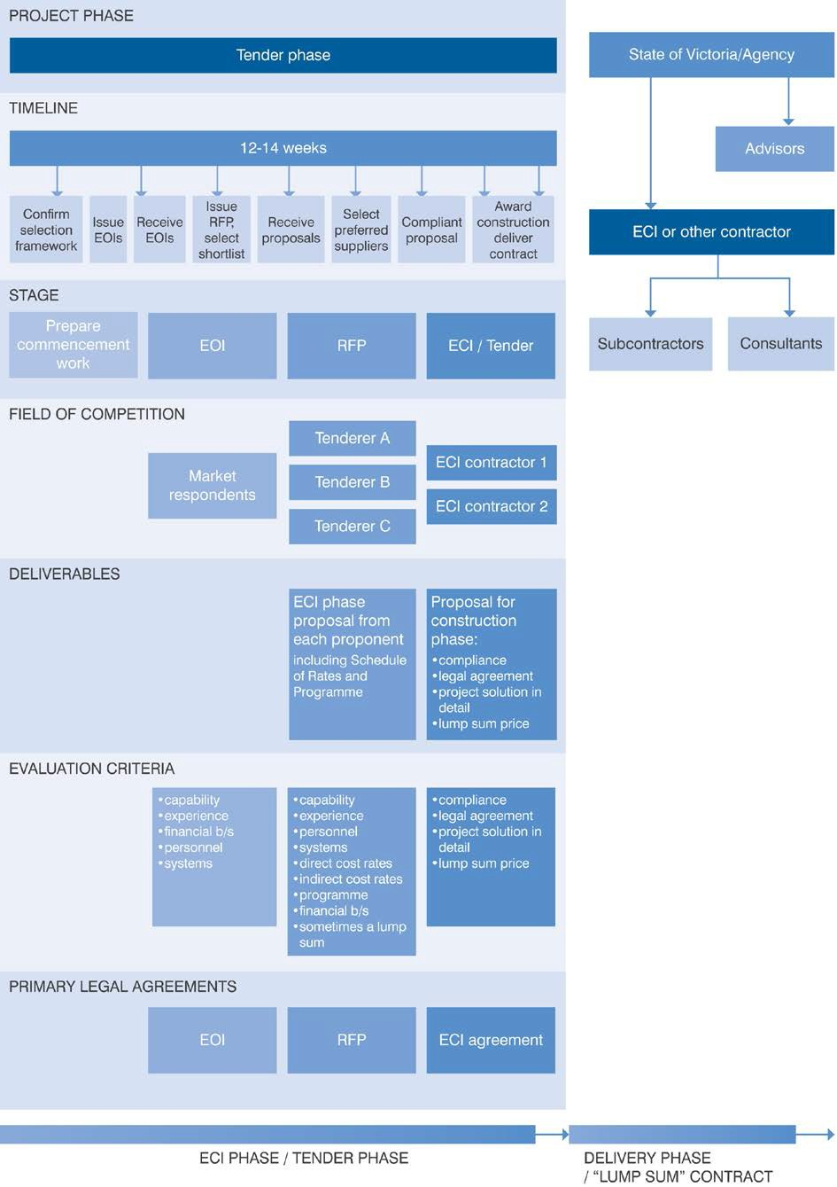

Figure 9 A typical early contractor involvement model

Public-private partnerships

A PPP is a long-term contract where government or users pays the private sector (typically a consortium) to deliver infrastructure and related services. Internationally, a PPP is often referred to as a PFI (private finance initiative).
The principal features of a PPP are:
    - provision of a service involving the creation of an asset with private sector design, construction, financing, maintenance and delivery of ancillary services for a specific period;
    - a contribution by government through land, capital works, risk sharing, revenue diversion, purchase of the agreed services or other supporting mechanisms; and
    - the private sector receiving payments from government (or users in economic infrastructure) once operation of the infrastructure has commenced, contingent on the private sector’s performance in supplying the services throughout the asset’s lifetime.
The State is typically seeking the whole-of-life innovation and efficiencies that the private sector can deliver in the design, construction and operation phases of the project.
The State’s responsibilities for managing the project are therefore different from all the other delivery models. The State becomes a purchaser of asset-based services that are paid for according to performance. The State allocates certain risks to the private party, locks in whole-of-life budgets and quality standards, and facilitates focus on its core business.
PPPs can be delivered through various delivery models where the provider takes on responsibility for non-construction functions in addition to the construction role. In each model, the provider undertakes a different combination of roles, for example:
    - design, build, finance, operate (DBFO)
    - design, build, finance, maintain (DBFM).
In a typical PPP, the private provider not only builds the facility but also operates or maintains it to specified standards over a long period, often 25 years or more. The government:
    - prepares an output-based specification rather than a prescriptive specification;
    - engages a provider to deliver services over a long term (e.g. 20–35 years or more);
    - requires the provider to design, finance, construct, maintain and operate the facility including providing ancillary services such as cleaning, security, facilities management and catering (or some combination of those functions) and takes the risk for those functions;
    - generally makes no payments to the provider before the facility has commenced operations;
    - provides payments over the term of the contract based on services delivered against the achievement of KPIs, ensuring the infrastructure is maintained over its lifetime; and
    - usually retains ownership of the asset at the end of the contract term.
Figure 10 illustrates one type of PPP. The State engages a private sector entity responsible for construction, financing, operations and maintenance. The State has certain ‘step-in’ rights in the event of default by the private party.

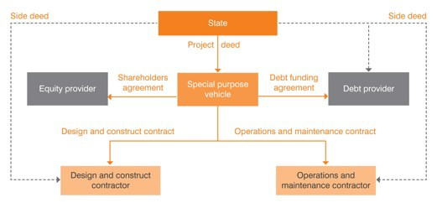
Figure 10 Example of a PPP structure

The use of PPPs in Victoria is governed by the Partnerships Victoria framework. The framework requires compliance with both:
    - the National PPP Policy and Guidelines available on the Infrastructure Australia website; and
    - the Partnerships Victoria requirements and annexures listed on the Partnerships Victoria website.
It is important to note that under the National PPP Policy and Guidelines, PPPs must be considered as a procurement option when planning for any capital expenditure over $50 million.

Competitive dialogue

The ‘competitive dialogue’ model involves the contracting agency and short-listed vendors working together in a structured way to develop and refine the proposed solution for the project requirements.
The competitive dialogue approach is most relevant for complex projects where the agency specifies an outcome-based requirement but either cannot or does not want to prescribe the solution. So far, it has been used most frequently on ICT projects. Project complexity may arise, among other things, from the use of complex ICT infrastructure, introducing new technology for business transformation or seeking an alternative service model. Variants of the competitive dialogue model exist and some variants are known as ‘interactive vendor engagement’, ‘joint design’ and ‘early contractor involvement’.
Key benefits associated with competitive dialogue, when conducted properly, include:
    - increased potential for innovative solutions that are fit-for-purpose;
    - greater confidence in the quality of the solution through increased interaction between the agency and the vendor during procurement;
    - reduced transition risks as vendors have been involved with the agency in solution development;
    - greater opportunities for the agency to balance service scope, quality and budget imperatives; and
    - improved focus for the short-listed vendors to refine and agree to the solution approach under competitive pressure.

Typical structure of competitive dialogue

A competitive dialogue is typically implemented in three phases:
      - pre-qualification phase;
      - dialogue phase; and
      - offer/award phase.
The pre-qualification phase is typically conducted by issuing an EOI. It involves selecting vendors that are allowed to participate in the dialogue process.
The dialogue phase involves structured exchange of information and collaborative work, in a competitive environment, between the agency and the short-listed vendors to refine and optimise the proposed design. The dialogue phase could be repeated a number of times, with each repetition leading to further short-listing of vendors participating in the dialogue. In projects involving ICT infrastructure or services, a key consideration in this phase is finding the right balance between making changes to the business processes and the extent of solution customisation.
The offer/award phase takes place once the dialogue has completed, and the vendors remaining at the end of the dialogue have put forward a final tender incorporating their proposed solution.

Key considerations in undertaking competitive dialogue

Competitive dialogue can be a complex process requiring considerable skills, experience, resources and detailed planning. The outcome of the solution is highly dependent on the quality of the dialogue between the agency and the short-listed vendors. The following are some of the key issues that require careful consideration:
      - Competitive dialogue is most relevant for those services/requirements that are specified on an outcomes basis, including initiatives requiring service model redesign.
      - There can be a high cost of participation in the procurement process for both the agency and the vendors due to the iterative process involved. Small- and medium- size vendors may find it difficult to participate. To ensure a competitive environment, the agency needs to consider cost reimbursement to vendors participating in the dialogue.
      - The agency needs to be well prepared in terms of skills, market testing and assessment of service needs prior to undertaking competitive dialogue. The agency should be clear about its information needs during the process and only seek information directly relevant to meeting the objective of relevant phase of the process. Unstructured and excessive information requests can lead to cost overrun and schedule delays.
      - Significant demand is placed on the agency in the technical, commercial and legal disciplines when conducting the dialogue. The contracting agency should not rely on vendors to provide key skills that are more appropriately sourced in-house.
      - The agency needs to have a clear understanding of its evaluation criteria to short-list vendors during the different phases of the competitive dialogue. In particular, the agency must have clear criteria for exiting the dialogue phase.
      - The agency may be tempted to ‘cherry pick’ components of different proposed solutions but needs to carefully assess the integration costs of such an approach. Further, some vendors may be reluctant to share relevant information due to intellectual property concerns.
      - There can be an increase to the risk factors associated with probity, skills gap and inadequate planning that could lead to cost and schedule overruns.
Agencies should pursue competitive dialogue as a procurement strategy on an exception basis and should not use it as an alternative to proper pre-procurement scoping, engagement and consultation. Competitive dialogue is not considered to be an appropriate procurement methodology for commodity ICT services or infrastructure.
In pursuing competitive dialogue or its variants, agencies should be very clear as to why the traditional procurement methods are unsuitable, and how they need to resource and structure the dialogue to manage key risks and ensure expected outcome. Key areas of focus that should be explored in the strategy include:
      - the nature of the services proposed to be subject to the competitive dialogue;
      - the objectives sought from the process – in terms of budget, scope, quality of the services;
      - the capacity of the agency to undertake competitive dialogue and manage the associated risks;

      - the number (and skill set) of vendors invited to participate in the dialogue;
      - the minimum specification level/criteria to be imposed on vendors;
      - the number of phases involved in the dialogue and associated short-listing/selection criteria;
      - the composition of dialogue in terms of themes, information content, key outputs;
      - constraints on the nature and number of solutions; and
      - tender assessment and award criteria.

5.10 Hybrid models

While this guideline describes particular procurement models, it is worth noting that the use of hybrid models of procurement (and therefore project delivery) is increasing. Hybrid models of procurement involve using some aspects of one model of procurement and some of another. Hybrid models of procurement have evolved to better suit specific projects. This is the key to a good procurement strategy – that it relates explicitly and directly to the project. If there are aspects of one project methodology that particularly suit a project, project teams should consider incorporating them into the procurement strategy.

Table 4 summarises the key characteristics of each of these common procurement models.
Department of Treasury and Finance
Construct only Design and construct and variants | Managed Relationship Privately financed
Construct only Design and construct and variants | Construction Managing Early contractor  management contractor involvement | Alliance
Typical values

All values. Used for both ‘minor’ and ‘major’ works. |  | All values, but typically for contracts valued at  > $5 m. | All values, but typically for contracts valued at >  $10 m. | All values, but typically for contracts valued at > $50 m. | All values, but typically for contracts valued at  > $50 m. | All values, but typically for contracts valued at >  $50 m. | Typically for contracts valued at >  $50 m.
Typical procurement process
General process | Generally a single- | Generally a two- | Generally a single- | Single or two-stage | Generally two- | Generally a two-stage | May be a two-staged
 | stage process | stage process: | stage process | process. | stage process | process involving RFPs | process:
 | involving an RFQ or | - Stage 1 – EOIs or | involving an RFT | Selection is generally | involving a request | from the open market. | - Stage 1 – EOIs from
 | RFT. May involve | ROIs from the open | based on evaluation | based on an | for proposal (RFP) | Short-listed applicants | the open market
 | EOIs or  registrations of interest (ROIs) for | market  - Stage 2 – RFT stage, during which | of price and non-  price criteria (including the sum | evaluation of price  and non-price  criteria (including the | from the open  market.  In ‘competitive’ | are then invited to  participate in selection  workshops and the | - Stage 2 – RFP process, which includes interactive
 | higher value | short-listed | or percentage | fees payable to the | ECIs, two or more | owner selects two | workshops.
 | contracts. | applicants are | payable to the | managing | teams are selected | proponents to compete | A range of technical
Selection is invited to prepare construction contractor). and work on targets for cost and financial criteria
generally based on and cost designs to manager). This is generally independently of schedule and other key are used in the
evaluation of price approximately 20% followed by a either each other (with parameters. Through evaluation and

and non-price criteria (weighted heavily towards price), with some project owners taking into account past performance as part of the tender evaluation.
completion.
A mixture of price and non-price criteria are typically evaluated at both stages.
a single- or a two- stage contractual process – Stage 1 involves the managing contractor working with the project owner and its designers to refine the project documentation and progress the design, then submitting price to complete the
project owner input) to develop a preliminary design and risk-adjusted price for the works. Only the successful team will proceed to the construction phase. Selection for the ECI phase is based primarily on non-price criteria, although limited price criteria may
collaboration, the owner takes the lead in providing understanding and guidance on project objectives in the scope and risk development undertaken by the proponents through the TOC development process. The owner’s decision in selecting its preferred proponent to deliver the project is based on a balanced

selection process. Procurement costs for all parties are
generally high due to
the need for expert
advisers and lengthy contract negotiations. Some project owners may offer to reimburse short-listed respondents’ costs.

39

Construct only Design and construct and variants | Managed Relationship Privately financed
Construct only Design and construct and variants | Construction Managing Early contractor  management contractor involvement | Alliance

 |  |  |  | design and deliver the project under | also be considered. Payment for the | judgement of the price and non-price attributes
 |  |  |  | Stage 2. The  selection for Stage 2 is based on the same criteria as in Stage 1 with the addition of program, lump sum management fee, risk allocation and treatment of scope changes. | ECI phase is based on a fixed fee negotiated as part of the ECI agreement. Generally this fee should not exceed 50% of the estimated costs incurred by the suppliers for participating in the ECI phase. Following completion of the ECI phase, the principal selects one of these two | of the TOC development  outcome (including the proponent’s proposed project solution) and the team capability it offers. This includes the commercial and legal arrangements, etc., which have a significant implication on the final actual price paid. If the TOC is agreed a ‘project alliance agreement’ will be entered into by the owner and the preferred proponent, which governs the remainder of the alliance period.
 |  |  |  |  | suppliers for the
 |  |  |  |  | construction phase
 |  |  |  |  | under a design and
 |  |  |  |  | construct (D&C)
 |  |  |  |  | contract.
Use this model | The scope is | The owner does not | Scope of works | Complex or high-risk | The project is | In the delivery of | There is a complex
when: | defined and scope | need to specify their | cannot be clearly | projects with | complex, high risk | complex, high-risk | risk profile and
 | creep is unlikely. | requirements in | defined early in the | uncertain scope, risks | and has some | projects. | opportunities for
 | Risks are well | exact detail. | project. | or technology. | design unknowns. | The solution is unclear | appropriate risk
 | defined, clearly | The contractor is | Variations in scope | Greater flexibility is | There is a need to | and scope creep is likely. | transfer.
 | understood and | better placed to | or delays are likely | required to deal with | engage a | A high level of | The outputs can be
 | easily allocated. | manage design risks. | due to uncertainties. | project risks. | contractor early | innovation is required. | clearly defined and
 | There is little need | The agency requires | The project is | A high degree of | due to scarce | Risks are significant, | measured, enabling
 | or incentive for | a fixed price | complex and it is not | government | internal and | unpredictable and best | an output

Construct only Design and construct and variants | Managed Relationship Privately financed
Construct only Design and construct and variants | Construction Managing Early contractor  management contractor involvement | Alliance

designs for schools or police stations. There is limited
opportunity for
bundling services/
maintenance and creating whole-of- life efficiencies.
The project is small–medium sized and of short duration.

achievements. Where the government needs
to retain direct
control over the
works.
The agency wishes to have maximum involvement in early development phases.
There is a risk of not obtaining competitive tenders using other procurement delivery models.
innovation from the contractor. | contract.  The agency requires | possible to fully design some | expertise and input is available. | external resources. Price and time | managed collectively as the costs of transferring | specification and a performance-based
There is sufficient | a single point of | elements that are | Incentives for | certainty is | risk is prohibitive. | contract to be
time to complete | accountability for | required prior to | achieving cost and | paramount. | The owner can be | developed.
design | design and | work commencing | time targets can be | There is limited | closely involved and can | There is a
documentation | construction. | on other elements. | awarded. | delivery time. | add value. | competitive market .
prior to tendering. | Owner variations to | The contract has | Where ECI is | Risks can be better | There is a diverse and | There is a significant
Work is repetitive,  such as standard | scope are unlikely. | incentives to reward  cost and time | beneficial. | allocated. | demanding range of  stakeholders. | service component  and an opportunity

for bundling services.
Whole-of-life asset management is achievable and cost effective in a single contract package.
There is scope for innovation – the PPP approach focuses on output specifications, providing a wider opportunity to use competition as an incentive for private parties to develop innovative solutions in meeting these specifications.
There is scope to reduce government costs through third party asset utilisation.

Construct only Design and construct and variants | Managed Relationship Privately financed
Construct only Design and construct and variants | Construction Managing Early contractor  management contractor involvement | Alliance

Greater scope for competitive prices because of design certainty.
Advantages | Highest level of agency scope control and certainty – full | Single point of accountability for design and construction. | The principal shifts management responsibility to the construction | Potential for shorter design and construction program. | Tender process is less intensive and less costly.  Shortened delivery | All parties have shared responsibility for ensuring appropriate design. | Full integration of whole-of-asset lifecycle responsibilities.
 | design is endorsed | Administrative | manager. | Government can | time. | Provides flexibility to | Greater transfer of
 | prior to tendering. | efficiency. | The principal can | retain control of the | Experience and | modify design and | risk to the private
 | Contract value is | Potential to fast | retain a high degree | design phase. | knowledge is | allows ongoing changes | sector.
 | known before | track the project | of control over | Early involvement of | harnessed early in | to be incorporated | Opportunity for
 | construction | because | works. | all project | the project | during construction. | innovation.
commences – construction can |  |  | Parts of the project | participants and | lifecycle. | Provides incentives to all | Performance
design commence ahead of |  |  | can proceed while | stakeholders. | Increased | parties to complete the | standards are in
complexities are full design |  |  | other aspects are | Reduces demand on | opportunities for | project on time and on | place.
resolved before documentation.  contract award. Overall project cost |  |  | still being  documented. | agency project  management | innovation.  Better integration | budget.  Cost of adversarial | Transfer of lifecycle cost risk encourages
Lower cost of can be reduced by  tendering. contractor |  |  |  | resources.  Often has | of construction  methods. | conduct, claims and  disputes is eliminated in | efficient design and  quality construction.
Larger pool of involvement and  potential innovation in the  tenderers, design process. |  |  |  | mechanisms for  resolving issues and sharing benefits. | Potential for early procurement of materials. | the ‘no blame’ culture.  Can deliver highly complex projects with | Overall design and fit for purpose risk lies with the private
increasing Contractor normally  competition. warrants the design. |  |  |  |  | Fewer expected | uncertain risks that  would otherwise be | sector.

Government can
variations during construction.

difficult or impossible to deliver.
Culture promotes innovation. Promotes project
Lower cost of asset development and service provision.
Less long-term demand on agency resources.

Construct only Design and construct and variants | Managed Relationship Privately financed
Construct only Design and construct and variants | Construction Managing Early contractor  management contractor involvement | Alliance

control stakeholder management.
management efficiencies. Stakeholder issues can
be well managed.
All parties commit to finding ‘best for project’ solutions.
Ability to attract greater numbers of tenderers for complex projects.
Payments commence after successful commissioning.

Disadvantages (and issues that may need managing)

No single point of responsibility due to separate design and construction contracts.
Potential for claims and delays due to design deficiencies.
Minimum opportunity for cost value management or innovation input from contractor.
Government retains design risk. Government acts
as project
manager, requiring
skills and resources. Adversarial
contract

Longer tender periods needed to allow tenderers to assess design risk.
Principals may pay a premium to transfer design risk.
Lack of focus on lifecycle costs and considerations.
Government retains whole-of-life costs. Government may be
liable for time and
cost overruns.

No single line of responsibility.
The principal must claim directly against the trade contractors and consultants if things go wrong – there is limited penalty on the contract manager for cost and schedule risks.
Principal has little cost certainty. Project is highly
dependent on
participant cooperation. Difficulties in
allocating risks and
enforcing timely
completion. Obligations can be administratively

The government and contractor share time and cost risks until the end of design development.
Difficulty setting cost targets with limited design details.
Limited number of potentially suitable managing contractors may lead to higher cost in management margins.
Lack of focus on lifecycle costs and considerations.

Greater involvement of agency senior staff in early stages.
Additional costs resulting from ‘options costing’ by contractor and designer ideas being considered.

Requires all parties to be committed to collaboration – success relies on teamwork.
Requires ongoing involvement of senior staff with authority to resolve issues.
Cost to establish and maintain relationships can be high.
Government and industry have less experience in alliancing than other models.
Government bears cost and design risk. Government’s recourse
in the event of
catastrophic failure is
limited.

Success relies on well-defined functional and service specifications.
Significant stakeholder resources may be required during evaluation.
Changes to design may require contract negotiations.
Ability to make variations needs to be addressed in the contract.
Higher agency tendering and resourcing costs will need to be offset against potential cost savings.

Construct only Design and construct and variants | Managed Relationship Privately financed
Construct only Design and construct and variants | Construction Managing Early contractor  management contractor involvement | Alliance

 | environment. Potential lack of focus on lifecycle  costs and  considerations. |  | complex.  Lack of focus on lifecycle costs and considerations. |  |  |  | Requires significant internal skills.  Need to educate stakeholders if they are unfamiliar with the process.
Risk allocation
Design risk | The risk of any | The contractor | The project owner | Typically, the | Design risks are | Design risk is shared – | The private sector
 | design-related | bears the risk of | generally bears the | managing contractor | negotiated and | but NOPs’ exposure may | partner(s) generally
 | matters rests with | design, including | design risk. | assumes | allocated to the | be capped as part of the | assumes the
 | the project owner, | warranting the |  | responsibility for | party best placed | ‘pain share, gain share’ | financing and cost
 | which must seek | design’s fitness for |  | design coordination, | to control each | arrangement. | risks of the design,
 | recourse from | purpose. |  | including design | aspect of the risk – |  | and is required to
 | external design |  |  | development and | generally the |  | warrant the design’s
 | consultants |  |  | documentation | contractor. |  | fitness for purpose.
 | regarding design- |  |  | process risks, and
 | related errors or |  |  | manages the design
 | omissions. |  |  | process to ensure
 |  |  |  | adherence to the
 |  |  |  | agreed program. The
 |  |  |  | project owner bears
 |  |  |  | design cost risks
 |  |  |  | under any ‘cost plus’
 |  |  |  | arrangement.
Construction | The contractor | The contractor | Individual trade | The managing | The construction | Risk is shared (including | The private sector
cost risks | bears the risk | generally bears the | contractors bear the | contractor usually | risk is negotiated | for force majeure | partner(s) generally
 | under a lump sum, | risk, except for | risk under lump sum | takes all construction | but largely borne | events), but the NOPs’ | assumes the
 | with the risk | some latent | arrangements, with | cost risks, | by the contractor, | exposure may be | majority of the risk,
 | partially borne by | condition and | the risk partially | particularly in | given the time | capped as part of the | except for sovereign
 | the project owner | permit-related risks. | borne by the project | circumstances where | allowed in the ECI | ‘pain share, gain share’ | risk and changes to
 | under a schedule | Project owners may | owner where there | there is a guaranteed | phase to | arrangement. | the regulatory
 | of rates for items | seek prices based on | is a schedule of rates | maximum price. | investigate project |  | environment, which
 | outside specified | certain risks being | for items outside the | The project owner | risks, including |  | may be retained by

Construct only Design and construct and variants | Managed Relationship Privately financed
Construct only Design and construct and variants | Construction Managing Early contractor  management contractor involvement | Alliance

 | limits of accuracy. The project owner | priced ‘in’ or ‘out’ of the tenderer’s final | specified limits of accuracy. | generally assumes some cost risk | constructability. As with D&C, |  | the project owner. The sponsor will
 | generally assumes  some cost risk around latent | offer. | The project owner  generally assumes some cost risk | around latent  conditions and  permits/approvals. | project owners  may seek prices based on certain |  | typically allocate  significant risk to the construction
 | conditions and |  | around latent |  | risks being priced |  | contractor under a
 | permits/ |  | conditions and |  | ‘in’ or ‘out’ of the |  | D&C, with residual
 | approvals. |  | permits/approvals. |  | construction phase |  | risk borne by the
 |  |  |  |  | offer. |  | sponsor and
 |  |  |  |  |  |  | financiers.
Construction | The contractor | The contractor must | Quality-related risks | The managing | The contractor | Construction must meet | The private sector
quality risks | must construct the | construct the works | generally rest with | contractor must | must construct the | the quality standards | partner(s) must
 | works in | in accordance with | the individual trade | construct the works | works in | outlined in any agreed | construct the works
 | accordance with | the approved design | contractors engaged | in accordance with | accordance with | key result areas. The | in accordance with
 | the design and | and specifications. | to deliver specific | the approved design | the agreed design | quality risk is shared | the agreed design
 | specifications. |  | portions of the | and the | and specifications. | between the alliance | and specifications.
 |  |  | works. | specifications. |  | participants.
 |  |  |  | The managing
 |  |  |  | contractor warrants
 |  |  |  | that the construction
 |  |  |  | will accord with the
 |  |  |  | design intent and is
 |  |  |  | responsible for the
 |  |  |  | planning and
 |  |  |  | implementation of
 |  |  |  | quality assurance
 |  |  |  | covering all of the
 |  |  |  | works undertaken by
 |  |  |  | the sub-contractors
 |  |  |  | etc. The managing
 |  |  |  | contractor generally
 |  |  |  | is precluded from
 |  |  |  | self-performing
 |  |  |  | construction and

Construct only Design and construct and variants | Managed Relationship Privately financed
Construct only Design and construct and variants | Construction Managing Early contractor  management contractor involvement | Alliance

 |  |  |  | design work.
Construction | Each party bears | Each party bears the | Time-related risks | The managing | Each party bears | Risks are shared – but | The majority of the
time risks | the risk of delays | risk of delays caused | generally rest with | contractor may only | the risk of delays | the NOPs’ exposure to | risks are allocated to
 | caused by it or on | by it or on its behalf. | the individual trade | provide a | caused by it or on | risk may be capped as | the private sector
 | its behalf. | Liquidated damages | contractors engaged | ‘reasonable | its behalf. | part of the ‘pain share, | parties, with the
 | Liquidated | provisions may | to deliver certain | endeavours’ promise | Some risks that are | gain share’ | construction
 | damages | apply if the | portions of the | with regard to time, | difficult to allocate | arrangement. | contractor bearing
 | provisions may | contractor fails to | works, as per | with individual | may be shared, |  | much of the
 | apply if the | achieve practical | standard construct | subcontractors and | including ‘neutral’ |  | construction time
 | contractor fails to achieve practical | completion by the nominated date. | only arrangements. | consultants liable for  meeting nominated | risks like force majeure, with an |  | risk.
 | completion by the  nominated date.  The contactor may | The contactor may receive an EOT for delays specified in |  | completion dates.  Alternatively, the managing contractor | ability to seek time  (but not costs)  under the contract.
 | receive an | the contract. |  | takes on all | Liquidated
 | extension of time |  |  | construction time | damages may
 | (EOT) for delays |  |  | risks on the basis of | apply, and the
 | specified in the |  |  | ‘target’ dates that, if | contractor risks
 | contract. |  |  | not met, may result | any early finish
 |  |  |  | in the reduction of | incentives if time
 |  |  |  | incentives. | frames are not
 |  |  |  |  | met.
Maintenance | Borne by the | Borne by the project | Borne by the project | Borne by the project | Borne by the | Borne by the project | The private sector
and/or operation | project owner, | owner, unless a | owner. | owner. | project owner. | owner, unless the | entity typically
risks | unless a | maintenance or |  |  |  | alliance includes a | assumes
 | maintenance or | operations |  |  |  | maintenance/operations | maintenance and
 | operations | component is |  |  |  | component. | operating demand
 | component is | included in the |  |  |  |  | risk.
 | included in the | contract.
 | contract.
Potential for innovation

Consideration of Strong designer– The involvement of The project owner, The project owner, The competition The long-term level

Construct only Design and construct and variants | Managed Relationship Privately financed
Construct only Design and construct and variants | Construction Managing Early contractor  management contractor involvement | Alliance

 | alternative tenders can result in some degree of innovation; however, under | contractor relationship can result in innovative outcomes.  Where a | the construction manager at an early stage can result in strong constructability | contractor and designer generally work together in an integrated project team during Stage 1, | contractor and designer generally work together in an integrated project team | between the two suppliers in the TOC development stage and the input from the owner drives early | of risk transfer to the private sector partner results in a very high potential for innovation
 | some standard | maintenance or | input into the | which generally | during Stage 1, | innovation capture and | particularly at the
 | forms of contract | operations | design. | results in a high | which generally | a robust tender price for | design stage as there
 | there is no | component is |  | degree of innovation | results in a high | the construction phase. | is a strong incentive
 | significant | included, there is an |  | into the design and | degree of | There is very high | for innovative
 | potential for  innovation during the construction | incentive to develop innovative solution. |  | its constructability. | innovation into the  design and its constructability. | potential for innovation,  with input from the project owner, | solutions to meet  durability and other whole-of-life
 | phase. |  |  |  |  | throughout the | requirements.
 |  |  |  |  |  | construction stage.
Pricing mechanism
 | Generally lump | Generally lump sum. | Construction | Pricing for Stage 1 | Pricing for Stage 1 | The non-owner parties | Payment linked to
 | sum and/or | May include some | manager paid a fee – | usually on a time | usually on a time | are typically guaranteed | performance.
 | schedule of rates. | schedule of rates | potentially a | basis, using agreed | basis, using agreed | reimbursement of their | Payments are
 |  | components. | percentage of | rates and margins. | rates and margins. | direct project costs and | abated if KPIs are
 |  |  | construction cost.  Individual works and trades contracts are generally priced as | Pricing for Stage 2 generally ‘cost plus’ (to a guaranteed maximum prices). | Pricing for Stage 2 generally a risk- adjusted lump sum, potentially | payment of corporate  project overheads in an  open-book arrangement. | not met.
 |  |  | lump sums or  schedule of rates (paid by the construction manager or directly by the project owner). | Incentives are commonly included, tied to achievement of target price and/or other nominated targets. | with some  schedule of rates components and provisional items.  Incentives are commonly included. | In addition, if actual  delivery is better than the agreed targets, parties share the reward (‘gain share’). Conversely, if delivery does not meet agreed targets, a pre-agreed
 |  |  |  |  |  | ‘pain share’ formula
 |  |  |  |  |  | applies.

Construction works | Construction works | Construction works | The construction | A management | The alliance | The governance
commonly | commonly overseen | are overseen by the | works are overseen | team, which | arrangement is | arrangements in a
overseen by a | by a | construction | by the managing | includes the | governed by an alliance | PPP delivery model
superintendent, | superintendent, PR | manager, who | contractor, with | PR/PAP and | leadership team (ALT) | may be complex.
principal’s | or PAP. | generally | broad oversight by | contractor’s | and alliance | Typically, the
representative (PR) | Independent | administers all | the project owner. | project manager, | management team | arrangement
or principal’s | verifiers may be | individual trade | Resource | which manages | (AMT). | includes the project
authorised person | required for | contractors, with | commitment for | day-to-day project | Independent verifiers | owner and project
(PAP). | particular aspects of | broad oversight | project owners may | activities. | may be engaged for | sponsor, which may
Resource | the design or | from the project | be high during early | In some | particular aspects of the | be a syndicate of
commitment for | construction. | owner. | stages, due to the | circumstances, | design or construction. | banks and/or other

project owners
Construct only Design and construct and variants | Managed Relationship Privately financed
Construct only Design and construct and variants | Construction Managing Early contractor  management contractor involvement | Alliance
Contract administration

may be high depending on the degree of testing, auditing and general surveillance required.
Resource commitment for project owners may be high depending on the degree of testing, auditing and general surveillance required.
oversight of the
managing contractor’s procurement processes, after which the resources required to administer the works are minimised.
A facilitator may be required to help build relationships across the team(s).
independent
verifiers may be engaged for particular aspects of the design or construction.
A facilitator may be required to help build relationships across the team(s).
The level of resourcing is significant for all parties during Stage 1 due to the integrated nature of the project team and time commitments required to be made by senior personnel.
Facilitator(s) are commonly engaged to build relationships within and across the ALT and AMT for the life of the project.
A dispute resolution board may also be established to help resolve any disputes that cannot be managed at AMT or ALT level.
The time commitment required to effectively resource an alliance, including the level of commitment from senior executives, from both the public and private sectors, is significant.
Furthermore, an alliance
financiers,
construction
contractor and/or asset operator.
The complexity of the arrangement means that the project owner resources required at the front end of the project are very high but the degree of resourcing required to oversee the contractual arrangements is not generally significant once the project works are complete.

Construct only Design and construct and variants | Managed Relationship Privately financed
Construct only Design and construct and variants | Construction Managing Early contractor  management contractor involvement | Alliance

Table 4 Profiles and typical characteristics of delivery models4
project has a collective approach to risk, which means that the owner will share in construction and design risk (and opportunities) and is exposed to project risks that it would normally transfer to another party under a ‘hard dollar contract’ or a PPP. Therefore it is critical that the owner has a thorough understanding of the risks it faces under the alliance contract and has appropriate capabilities and resources to manage the contract.

4 Adapted from: Austroads, Building and Construction Procurement Guide – Principles and options, October 2012, www.austroads.com.au, pp. 51–55 with reference to the Government of Western Australia, Infrastructure Procurement Options Guide, November 2010 , http://www.finance.wa.gov.au/cms/content.aspx?id=11895



Error! No text of specified style in donwnert.
50

